**AI-DRIVEN EXPLORATION AND PREDICTION OF COMPANY REGISTRATION TRENDS WITH REGISTRAR**

**TEAM MEMBER ; STARWIN JENISH . S**

**REGISTER NO : 961221205304**

**Phase 5 submission document**

**EXPLORATORY DATA ANALYSIS (EDA)**

## Distribution of company registrations by industry, location, and size

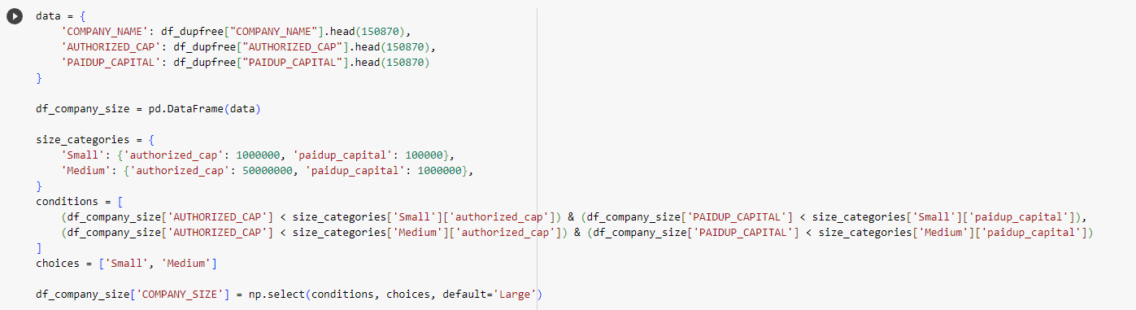

This segment of the code creates a new DataFrame df_company_size by extracting the first 150,870 entries for three columns: COMPANY_NAME, AUTHORIZED_CAP, and PAIDUP_CAPITAL from the df_dupfree DataFrame.

Companies are categorized into 'Small', 'Medium', and 'Large' based on their authorized capital and paid-up capital. Criteria for categorizing are defined in the size_categories dictionary.

conditions contain boolean expressions for categorizing companies as 'Small' or 'Medium'.

Using np.select(), companies satisfying the conditions are labeled 'Small' or 'Medium'. Any company that doesn't match these conditions defaults to 'Large'.

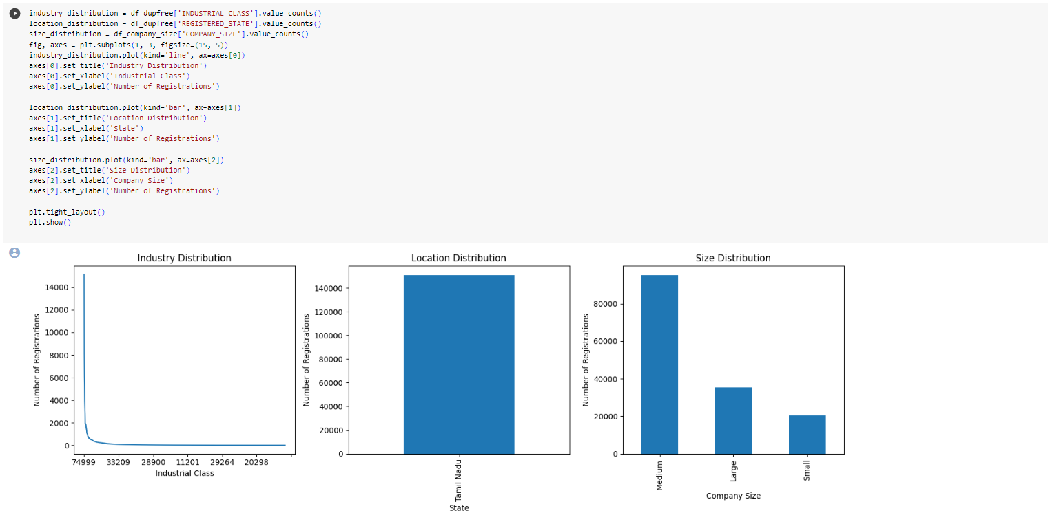

The distribution (counts) for industry classes, registered states (locations), and company sizes are calculated.

The visualization of the distributions is done using matplotlib.

plt.subplots(1, 3, figsize=(15, 5)): Initializes a single row of three subplots (charts).

plt.tight_layout() adjusts the spacing between the plots for better aesthetics.

plt.show() displays the visualizations.

## Company Registrations Trends Over Time

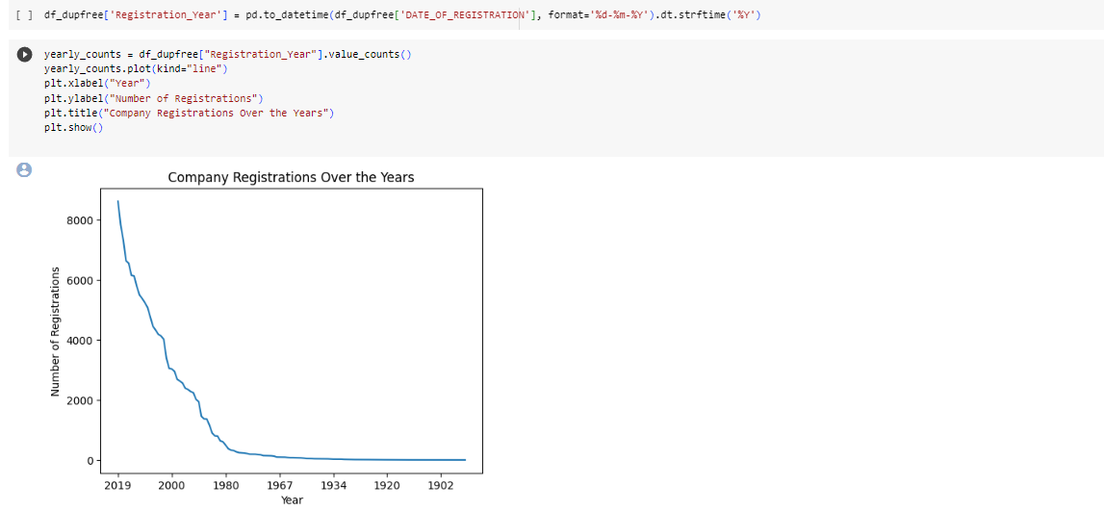

pd.to_datetime(...): The 'DATE_OF_REGISTRATION' column, which might be in a string format, is converted to a datetime object.

.dt.strftime('%Y'): Extracts only the year from the datetime object.

value_counts(): Calculates the number of registrations for each year.

The plot displays the yearly registration trend using a line chart.

The x-axis represents the year, while the y-axis shows the number of registrations for that year.

Relationships between different variables, such as company size, authorized capital, and paid-up

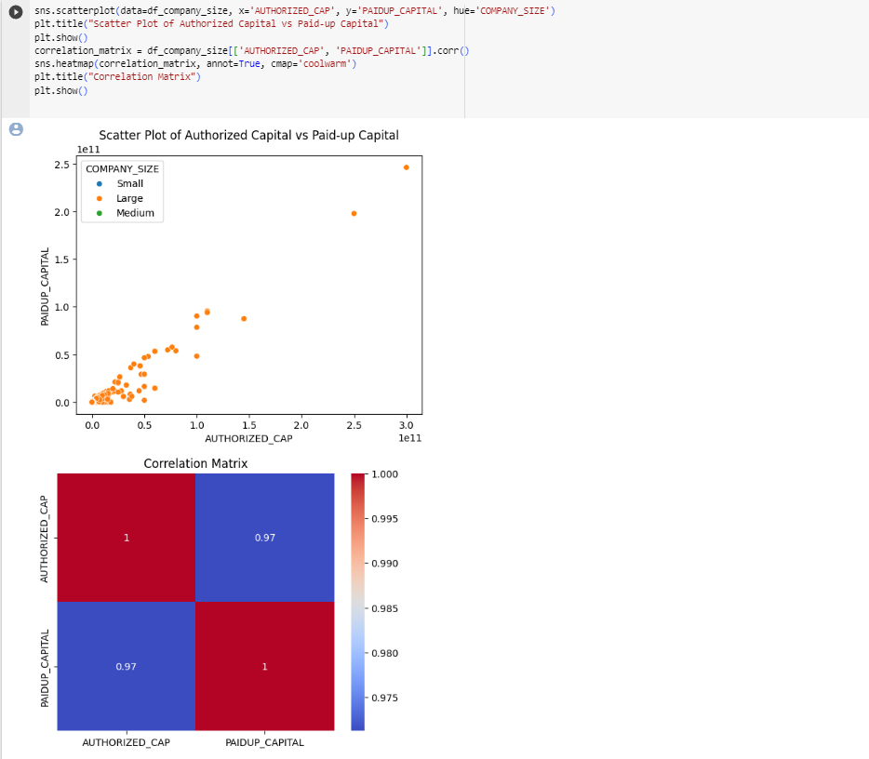

This scatterplot illustrates the relationship between authorized capital and paid-up capital, while the colors (determined by the hue parameter) represent the size of the company.

Correlation matrix is also obtained which helps in investigating relationships between company financial metrics (authorized vs. paid-up capital) and how company size might affect this relationship.

The dataset used is df_company_size DataFrame, which is derived from df_dupfree but only contains the first 150,870 rows and specifically the columns 'COMPANY_NAME', 'AUTHORIZED_CAP', and 'PAIDUP_CAPITAL'. The reason for using this subset may be to focus on a specific segment of the data for more detailed analysis or due to computational efficiency.

**FEATURE ENGINEERING:**

Age of Companies:

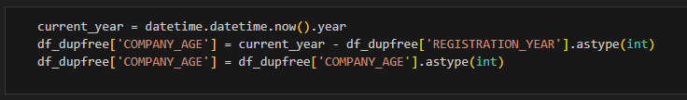

After running this code, the DataFrame df_dupfree will have a new column called 'COMPANY_AGE', and each row in this column will represent the age of a company calculated as the difference between the current year and the registration year. This age is expressed in years, as an integer.

This code is useful for creating a feature, 'COMPANY_AGE,' that can be used in data analysis, machine learning, or any other analysis related to the age of companies based on their registration year.

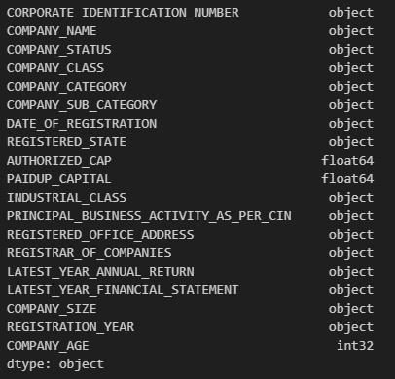

Label Encoding for “COMPANY_STATUS”:

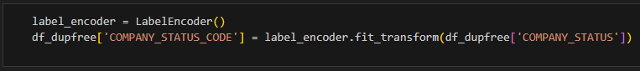

This takes a categorical column, 'COMPANY_STATUS,' in your DataFrame and converts it into a numerical representation. This is done by assigning a unique integer to each distinct category in the 'COMPANY_STATUS' column. The LabelEncoder ensures that each unique category corresponds to a specific integer, making it easier to work with in machine learning models or data analysis.

Number of Employees:

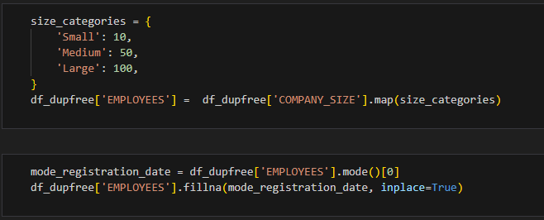

It involves mapping the values from 'COMPANY_SIZE' to new numerical values according to a predefined dictionary, 'size_categories.'

Calculate the ratio of ‘PAIDUP_CAPITAL’ to ‘AUTHORIZED_CAP’:



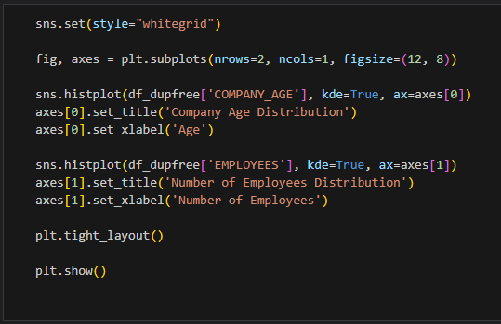

The code computes the ratio of paid-up capital to authorized capital for each company in the DataFrame 'df_dupfree' by performing element-wise division. Each row in the 'CAPITAL_RATIO' column will contain the result of dividing the 'PAIDUP_CAPITAL' value for that company by its corresponding 'AUTHORIZED_CAP' value.

Reasons for calculating the ratio:

* Financial Analysis
* Investment Decisions
* Regulatory Compliance
* Strategic Decision Making

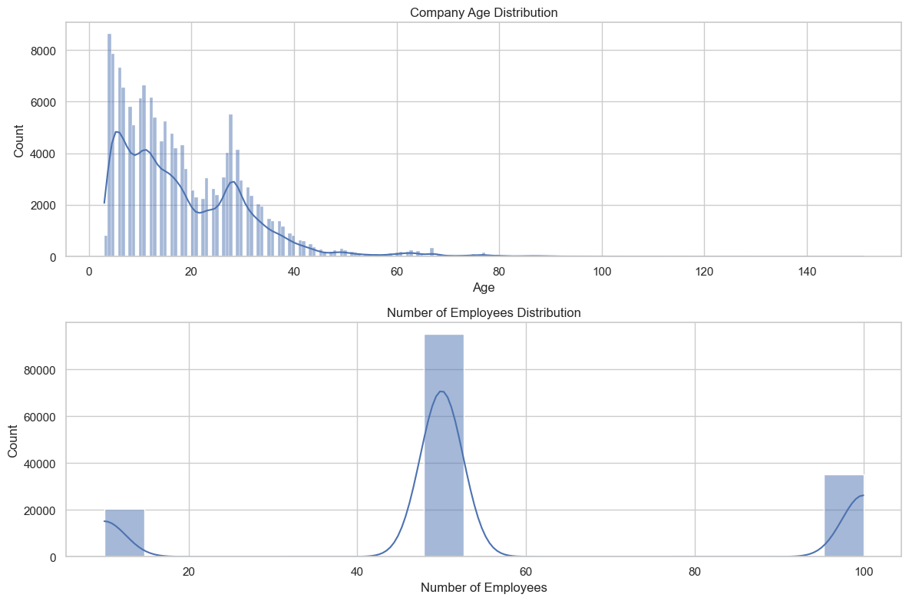

Extract ‘LATEST_YEAR_ANNUAL_RETURN’ year:

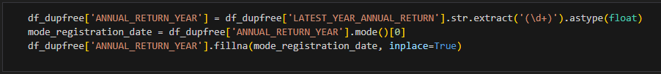

This extracts the year from the 'LATEST_YEAR_ANNUAL_RETURN' column, stores it in a new column 'ANNUAL_RETURN_YEAR,' and fills any missing year values with the mode of the available year values. This is a common data preprocessing step when working with date or time-related data to ensure that the data is in a consistent format and that missing values are appropriately handled.

Random Forest Algorithm:

import pandas as pd

from sklearn.model_selection import train_test_split

from sklearn.preprocessing import LabelEncoder

from sklearn.ensemble import RandomForestClassifier

from sklearn.metrics import accuracy_score, classification_report,confusion_matrix

import matplotlib.pyplot as plt

import seaborn as sns

df_dupfree = pd.read_csv("Data_Gov_Tamil_Nadu.csv", encoding="ANSI",low_memory=False)

df_dupfree = df_dupfree[['COMPANY_STATUS', 'COMPANY_CLASS', 'COMPANY_CATEGORY',

'AUTHORIZED_CAP',

'PAIDUP_CAPITAL',

'PRINCIPAL_BUSINESS_ACTIVITY_AS_PER_CIN']]

df_dupfree.dropna(inplace=True)

df_dupfree = df_dupfree.dropna(how="all")

mapping = {

    'Public': 1,

    'Private': 2,

    'Private(One Person Company)': 3,

}

df_dupfree['COMPANY_CLASS'] = df_dupfree['COMPANY_CLASS'].map(mapping)

mappingC = {

    'Company limited by Shares': 1,

    'Company Limited by Guarantee': 2,

    'Unlimited Company': 3,

}

df_dupfree['COMPANY_CATEGORY'] = df_dupfree['COMPANY_CATEGORY'].map(mappingC)

mappingS = {

    'ACTV': 1,

    'ULQD': 2,

    'LIQD': 3,

    'AMAL': 4,

    'DISD': 5,

    'NAEF': 6,

    'UPSO': 7,

    'STOF': 8,

    'D455': 9,

    'CLLP': 10,

    'CLLD': 11,

}

df_dupfree['COMPANY_STATUS'] = df_dupfree['COMPANY_STATUS'].map(mappingS)

label_encoders = {}

categorical_columns = ['COMPANY_CLASS', 'COMPANY_CATEGORY','PRINCIPAL_BUSINESS_ACTIVITY_AS_PER_CIN']

for column in categorical_columns: label_encoders[column] = LabelEncoder()

df_dupfree[column] = label_encoders[column].fit_transform(df_dupfree[column])

label_encoder_y = LabelEncoder()

df_dupfree['COMPANY_STATUS'] = label_encoder_y.fit_transform(df_dupfree['COMPANY_STATUS'])

X = df_dupfree.drop('COMPANY_STATUS', axis=1)

y = df_dupfree['COMPANY_STATUS']

X_train, X_test, y_train, y_test = train_test_split(X, y,test_size=0.2, random_state=42)

model = RandomForestClassifier()

model.fit(X_train, y_train)

y_pred = model.predict(X_test)

y_pred_decoded = label_encoder_y.inverse_transform(y_pred)

accuracy = accuracy_score(y_test, y_pred)

print(f"Accuracy: {accuracy}")

class_labels = label_encoder_y.classes_

y_pred_decoded = [reverse_mapping[label] for label in y_pred]

report = classification_report(y_test, y_pred_decoded, labels=class_labels, zero_division=1)

print("Classification Report:\n", report)

cm = confusion_matrix(y_test, y_pred)

plt.figure(figsize=(8, 6))

sns.heatmap(cm, annot=True, fmt='d', cmap='Blues',xticklabels=label_encoder_y.classes_,yticklabels=label_encoder_y.classes_)

plt.xlabel('Predicted')

plt.ylabel('True')

plt.title('Confusion Matrix')

plt.show()

Random Forest is an ensemble learning method, which means it combines the predictions of multiple individual models (decision trees) to make more accurate and robust predictions. It is widely used in various domains, including business and finance, for tasks such as classification, regression, and data exploration.

Here’s how the random forest algorithm works,

* Ensemble of Decision Trees
* Bootstrap Sampling
* Feature Randomness
* Voting or Averageness

This demonstrates the steps to prepare data, build a Random Forest classifier, and evaluate its performance in predicting the status of companies based on various features. The model's accuracy and classification report provide insights into how well it performs in classifying companies into different status categories. The confusion matrix visualization helps assess the model's performance further.

